ASSIGNMENT 4
Data Flow Diagram (DFD)
Skill-Based Project Collaboration System

Student: | Ghulamjillani
Professor: | Sajid Anwar
Date: | May 2026

1. Introduction

A Data Flow Diagram (DFD) is used to represent the flow of data within a system. It shows how information enters the system, how it is processed, stored, and transferred between different entities.

This assignment presents the Level 0 DFD (Context Diagram) and Functional Hierarchy for the Skill-Based Project Collaboration System.

2. Level 0 DFD (Context Diagram)

The Context Diagram represents the entire system as a single process and shows the interaction between external entities and the system.

External Entities
- Guest
- Registered User
- Project Owner
- Admin

Main System Process
- Skill-Based Project Collaboration System

Data Flows
Entity | Data Flows
Guest | - Sends registration/login requests  - Receives project information
Registered User | - Sends profile details and project applications  - Receives project recommendations and messages
Project Owner | - Sends project details and application decisions  - Receives applicant information
Admin | - Sends skill management updates  - Receives system reports and skill data

Context Diagram
The diagram below shows all external entities and their bidirectional data flows with the central system. Solid arrows indicate data sent to the system; dashed arrows indicate data returned to entities.

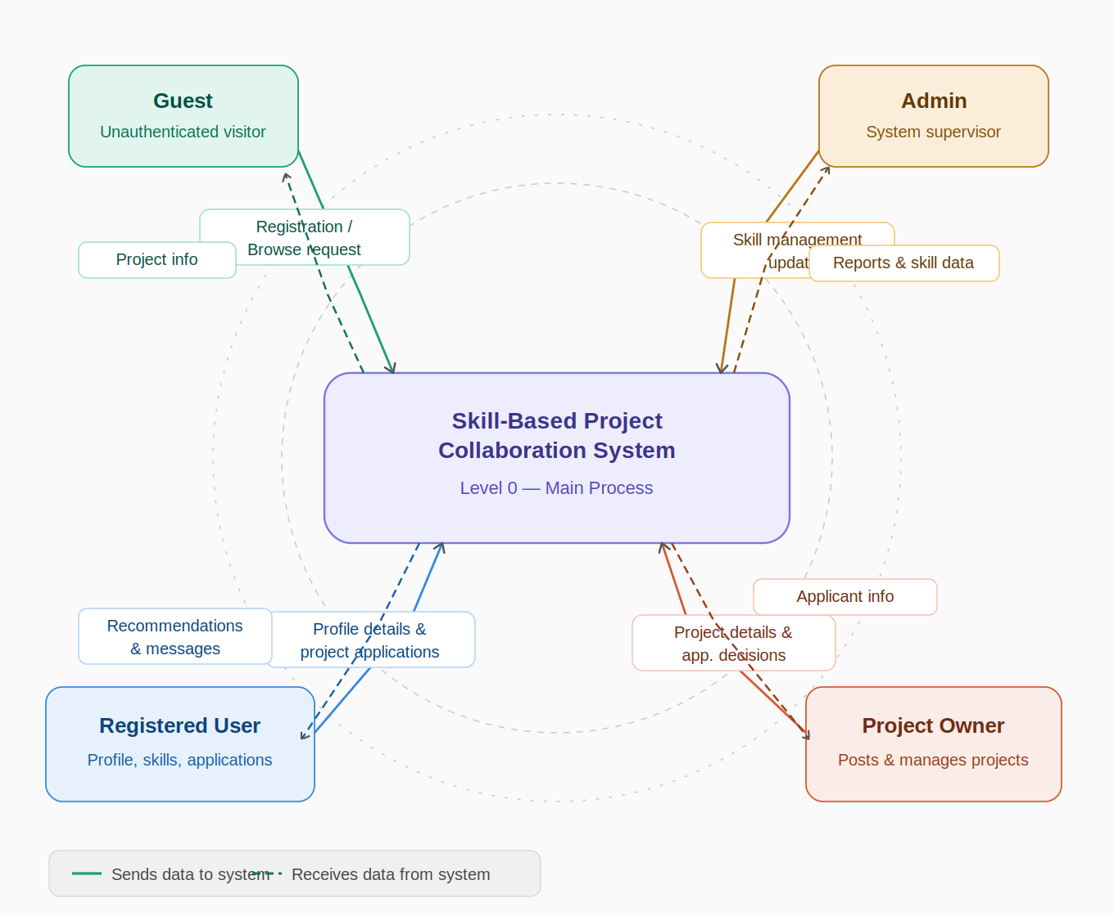
Figure 1: Level 0 DFD — Context Diagram for the Skill-Based Project Collaboration System

3. Functional Hierarchy

The functional hierarchy decomposes the system into its major functions and subprocesses.

Main System: Skill-Based Project Collaboration System

Module | Sub-Processes
1. User Management | - Register User  - Login User  - Manage User Profile  - Manage Skills
2. Project Management | - Create Project  - Edit Project  - Delete Project  - View Projects
3. Application Management | - Apply to Project  - Review Applications  - Accept/Reject Applicants
4. Communication Management | - Send Messages  - Receive Messages  - Store Chat History
5. Skill Management | - Add Skills  - Remove Skills  - Update Skill Database

4. Functional Hierarchy Diagram

The diagram below shows the complete functional breakdown of the system as a color-coded tree. Each branch represents one module; leaf nodes are individual sub-processes.

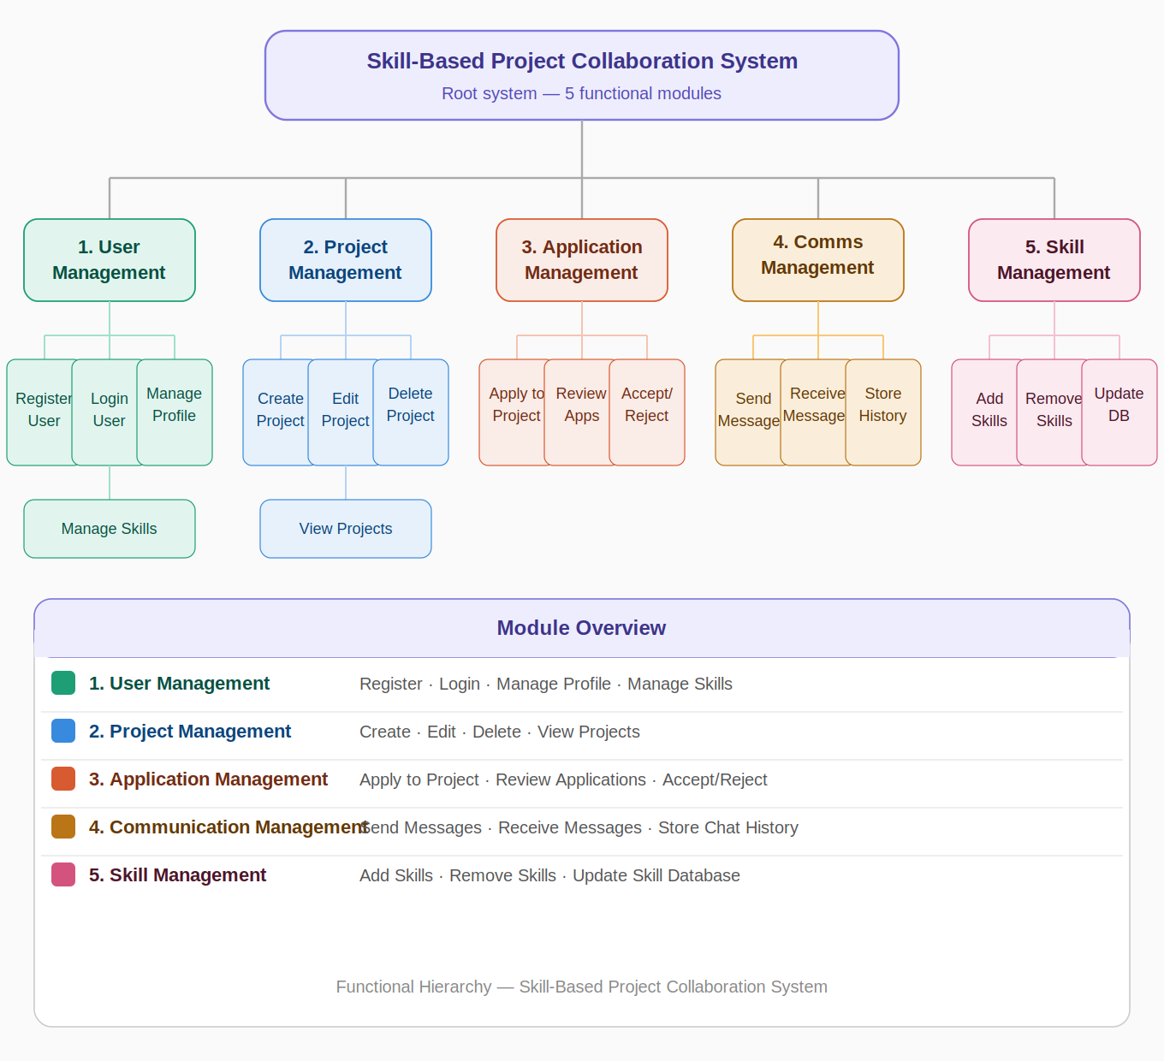
Figure 2: Functional Hierarchy — Skill-Based Project Collaboration System

5. Conclusion

The Data Flow Diagram provides a clear understanding of how data moves within the Skill-Based Project Collaboration System. The Context Diagram identifies the interaction between external entities and the system, while the Functional Hierarchy breaks the system into major functional modules for easier analysis and development.

